Name ____________________ IB SEHS Winter 2018

Due:

Please download a copy of this page and type your own individual results within the document...

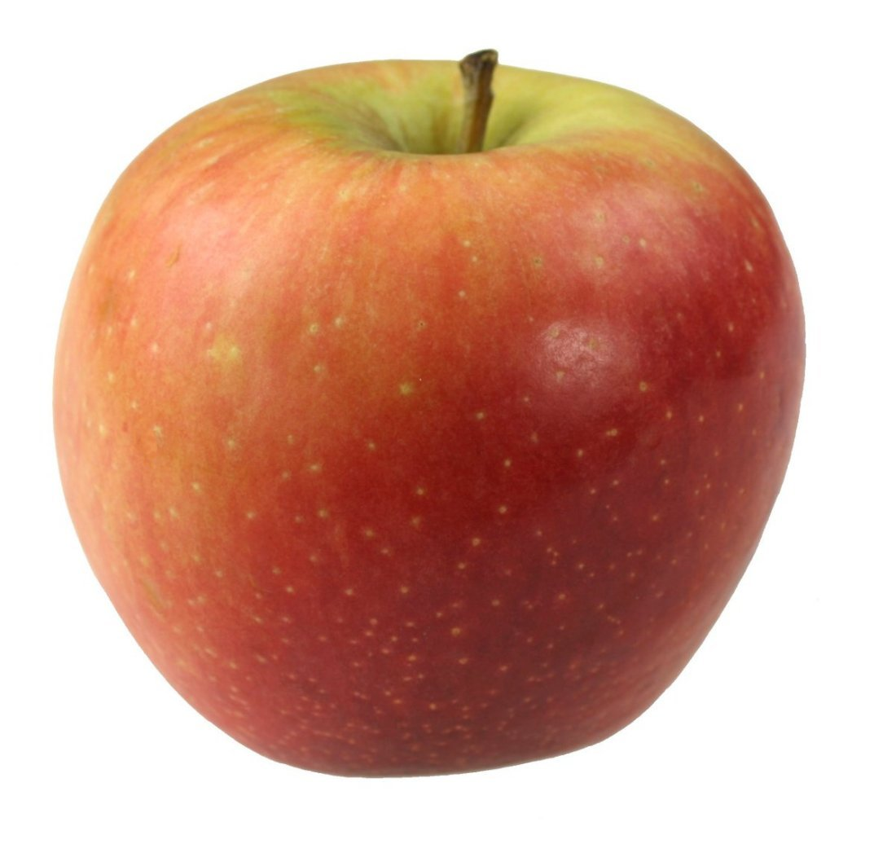
Do each task and bring in your results as you investigate

Task 1: Tracking your food intake.
You will need to track and log your food for four days. You will need to be able to access or know what your nutrient intake was for Carbs, Fats and Proteins.
You may use the link below or you may you an app on your phone like My Fitness Pal.

https://www.supertracker.usda.gov/

Day | Carbs (g) | Fats (g) | Proteins (g) | Total Calories
1
2
3
4

Task 2: Calculate your own personal Basal Metabolic Rate

- Read the following link then calculate out your own BMR (Show your work)
http://dailyburn.com/life/health/how-to-calculate-bmr/

2. Please read the link below and take at least 4 key point notes
http://www.eatright.org/resource/fitness/sports-and-performance/fueling-your-workout/basics-of-carbohydrate-loading-for-sports-performance

Why was this interesting?

Please read the link below and take at least 4 key point notes
http://www.eatright.org/resource/fitness/sports-and-performance/fueling-your-workout/how-teen-athletes-can-build-muscles-with-protein

Why was this interesting?

Please read the link below and take at least 4 key point notes
http://www.eatright.org/resource/fitness/sports-and-performance/fueling-your-workout/caffeine-and-exercise

Why was this interesting?

Please read the link below and take at least 4 key point notes
http://www.eatright.org/resource/food/vitamins-and-supplements/dietary-supplements/supplements-and-ergogenic-aids-for-athletes

I chose this one for a specific reason...Please tell me why this article is important….It’s short but still carries A LOT of weight.

Task 3
The Three Metabolic Energy Systems
http://www.ideafit.com/fitness-library/the-three-metabolic-energy-systems

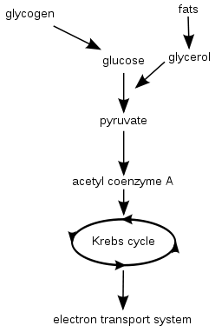
Please read the article above and jot down the appropriate notes

1.
2.
3.

