Name: Date:
Topic: Water Resources Questions Period:
Use the back for extra writing space.
1) Which of these population areas has the greatest urban water?
  - East Asia
  - Southeast Asia
  - Latin America/Caribbean
  - Western Asia

2) An aquifer is a permeable region of soil or rock that is saturated with water. The uppermost portion of the aquifer is referred to as _______.
  - groundwater
  - the water table
  - impervious rock
  - None of the above.
3) Water quantity is often measured in acrefeet. An acrefoot represents ________.
  - the amount of water needed to cover 1 acre with a depth of 1 foot
  - the amount of water needed to cover 1 acre
  - the amount of water needed to cover 1 cubic acre
  - None of the above
4) What group uses the largest supply of surface and goundwater?
  - households
  - agriculture
  - industry
  - All of these groups use equal amounts of water

5) Refer to the infographic below. Explain how salty ocean water can be recycled to become usable freshwater. (3 sentences minimum)
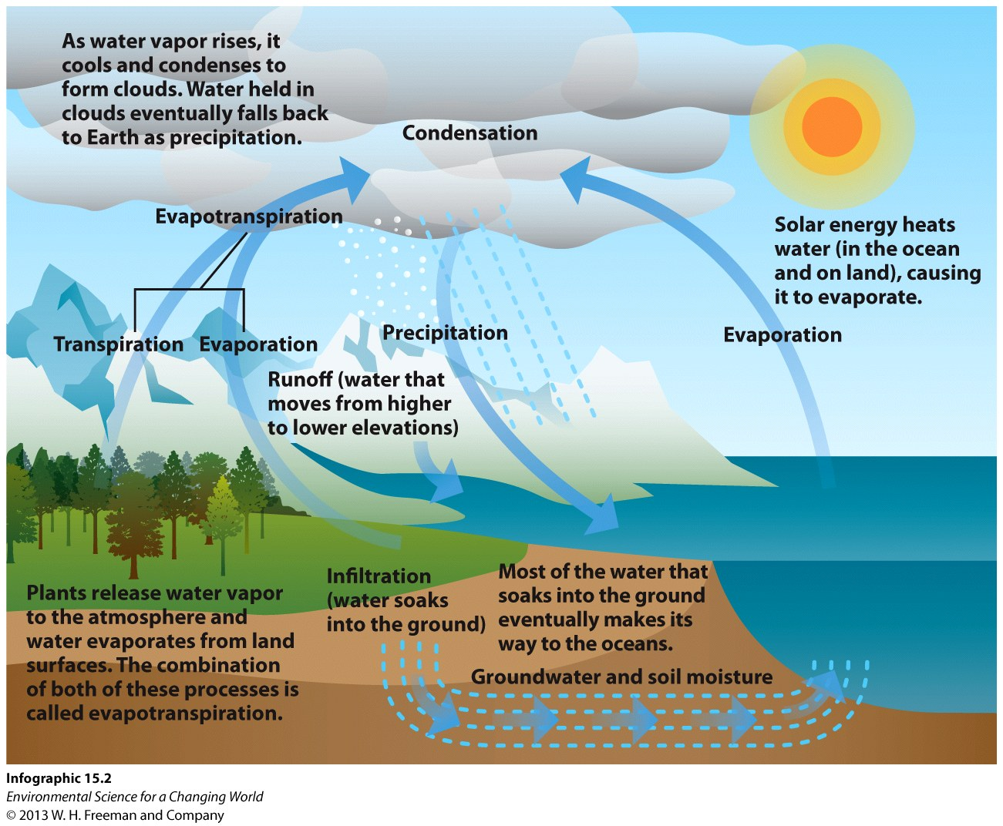

6) Explain how, over time, a deeper well for a larger house affects the water supply and the ability for shallower wells to access the water in an aquifer.

7) How do traditional wastewater treatment plants differ from wastewater treatment plants that mimic nature?

8) What could be some of the potential problems using wastewater treatment plants that mimic nature in colder environments?

9) Discuss two conservation strategies that individuals can use to reduce their water use and provide examples. Why are small changes important?

10) Many countries have constructed dams and reservoirs as a method to solve water shortages. What are some of the problems associated with reservoirs?

11) Explain why it is cheaper to conserve water than it is to purify, build a dam, or find “new” water.

12) How did the Orange County Water District solve the problem of saltwater intrusion into unconfined coastal aquifers?
A. It built a dam to block the seepage of saltwater into the aquifers.
B. It stopped using those aquifers as public water supplies.
C. It installed desalination plants to purify the water coming out the aquifers.
D. It began to pump highly treated sewage wastewater into infiltrated wells.
E. It built sea walls along coastal areas to keep out advancing waves
13) Desalination, the process that removes ________________ from water is _______________.

A. bacteria; cheap
B. salt and other minerals; expensive
C. pollution; a biomimicry process
D. sewage; mandated by the federal government
E. organic matter; facilitated by reverse osmosis

Extra Space for Short Answers

