Name: Date:
Topic: Water Resources Period:
Warm Up: List everything you do each day that requires water and try to estimate your daily usage (in gallons).

Where do you think your water comes from? How does it get cleaned/purified?

1) _______________ is water that has few dissolved ions, such as salt.
2) ______________ is used and _________________ water released after use by households, industry, or agriculture.
3) ____________ water is any body of water found above ground, such as oceans, rivers, and lakes.
- Water provides many ecosystem services to animals and plants. Humans are 75 ______ water. - We require __________________.
4) Facing water shortages, a county in California tried an ______________ approach: treating sewage water to create a source of ______________ water.
- Case: The Orange County Water District (OCWD) in Anaheim, CA has begun a groundbreaking project to turn wastewater into drinking water. They have been purifying HUGE amounts of wastewater and pumping it deep back underground .
5) Although 75 percent of Earth’s ___________ is covered by water, only 1/100 of 1 ___________ of that water is ____________ by humans.
- Nearly _____ percent of the freshwater on the planet is trapped in ____ caps and glaciers.
6) Wherever it is, water moves through a water cycle: cycling between __________ and liquid states.
- This process sends 17,000 ___________ gallons of water vapor into the atmosphere every year.
- Once aloft, that water _______________ (condensation) and may fall back to Earth as precipitation (rain, snow, sleet, etc.). Almost all precipitation falls in the ____________. But a tiny amount falls on land, which is what humans can ____________.
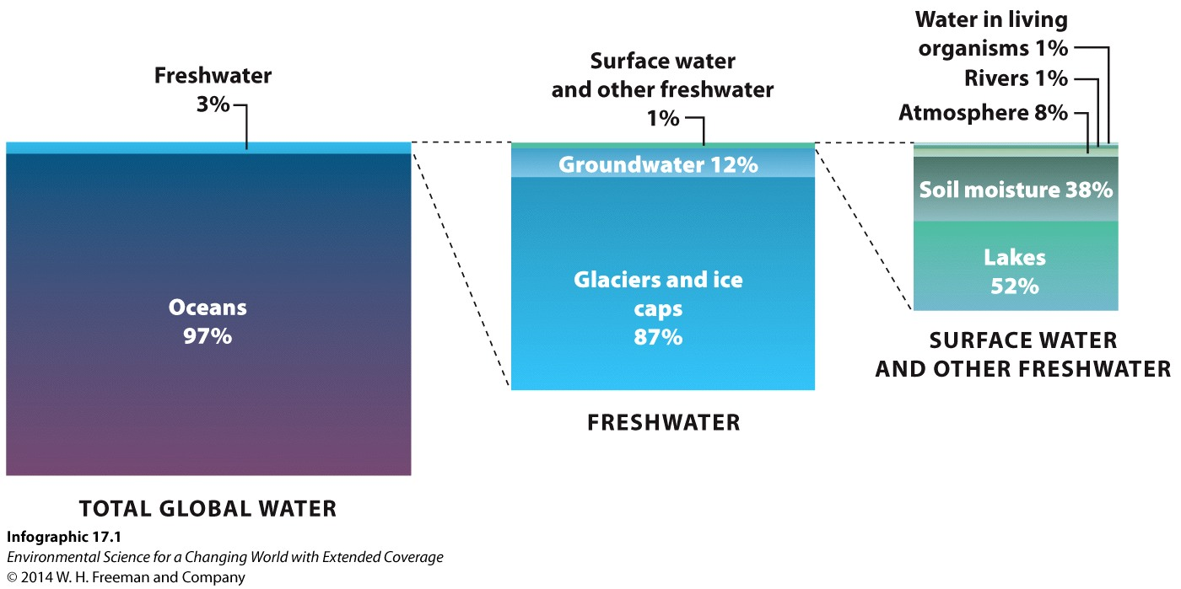

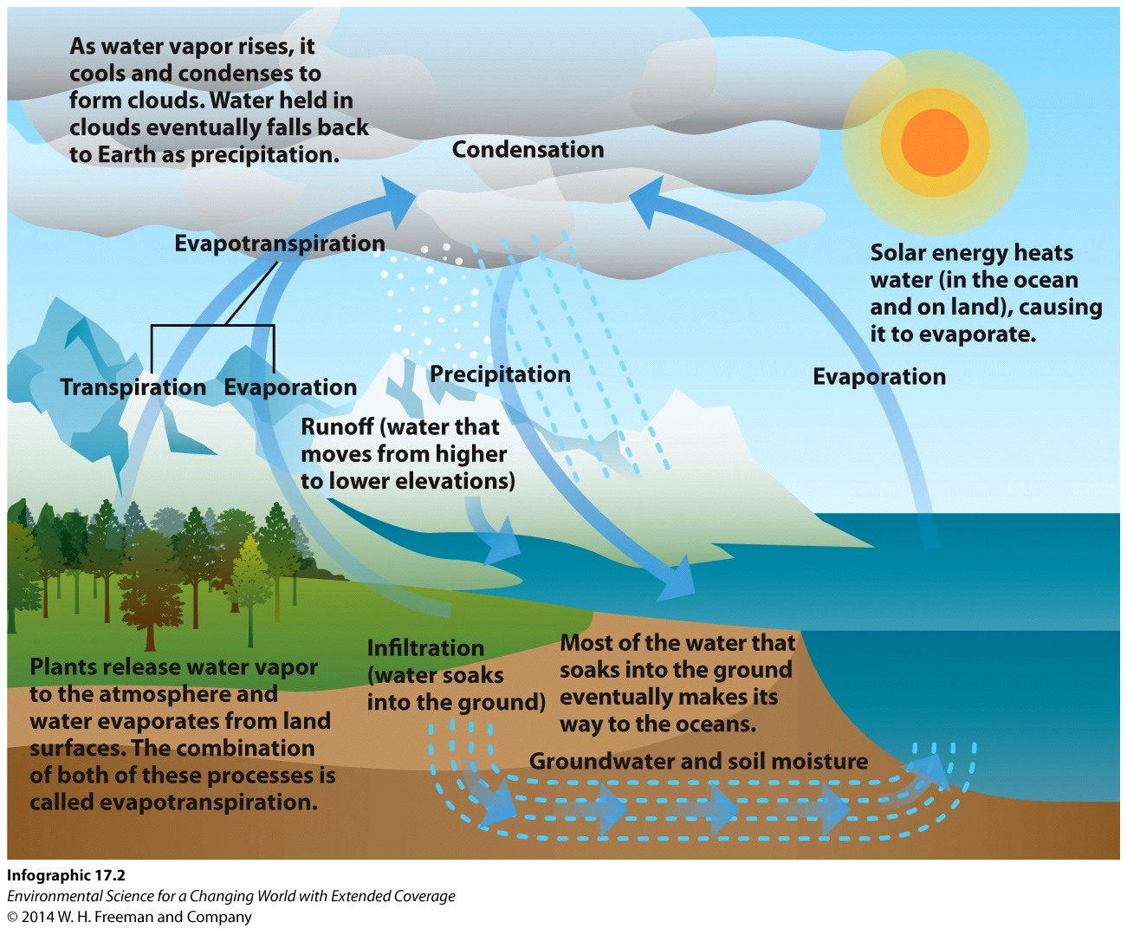

7) Ocean water is too ___________ for humans to consume, and can be toxic in large doses.
8) ______________ of nearby ocean water is expensive and uses a large amount of _________.
- This refers to any of several processes that ______________ some amount of salt and other minerals from saline water.
9) People don’t always live near ___________ sources of freshwater, making water scarcity a vital issue.
- The World Health Organization (WHO) estimates that 1 in 3 people – more than 2 ______________ – lack sufficient access to clean water.
- As populations _____________, so will water scarcity: the United Nations estimates 2 out of 3 people will face water _____________ by 2025.
- In many _______________ nations, people use nearby surface waters to meet their basic needs. Without improved sanitation, this water is contaminated with raw ____________ and other forms of contamination.
10) Water Usage: An _____________ of water is one-foot of water covering a one-acre surface. This would be about 300,000 gallons and support two families for a year.
- ______________ can only provide water equal to the replenishment rates.
- ______________ (City) use is actually dwarfed by agricultural drain.
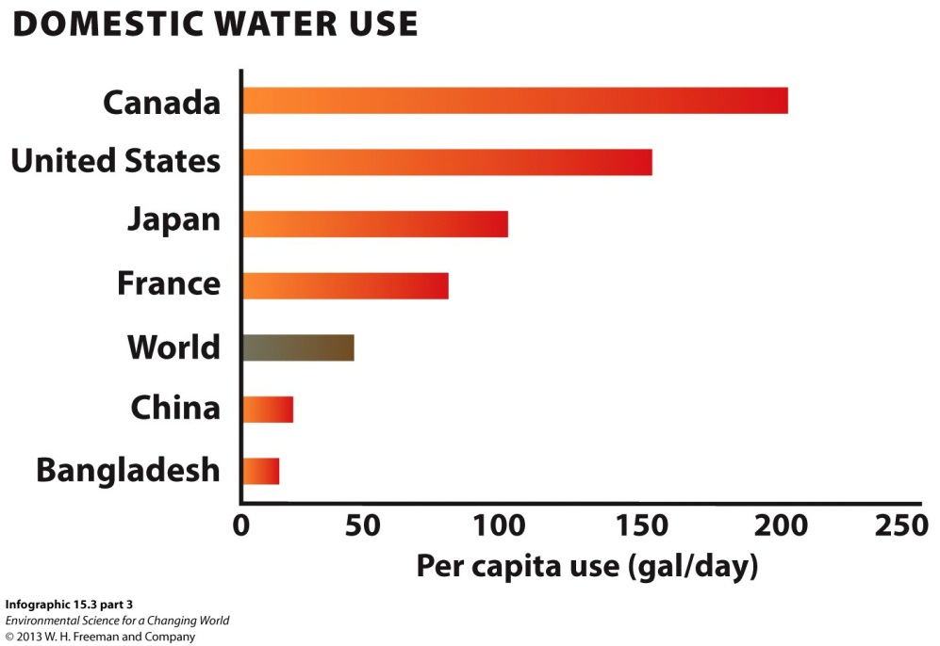
11) California faces several water challenges:
- Northern California gets freshwater from ____________ Sierra Mountain snowpack – which may ____________ with climate change.
- With climate change, this ________ melt is being reduced to critical levels each year.
- ______________ of the state’s water is in northern California, but two-thirds of the population is in the south. Shipping water south is costly – and earthquakes could cut off the water supply.
12) Many people – not just in California – rely on aquifers, _______________ regions of rock or soil permeated with water.
- Water _____________ down into the Earth naturally fills cracks and crevices while maintaining the water table and refilling the aquifer.
- In California, proximity to seawater and lower water tables have resulted in saltwater ________________ into the freshwater sources.
- California discovered saltwater was _____________ some aquifers – putting that water supply in jeopardy.
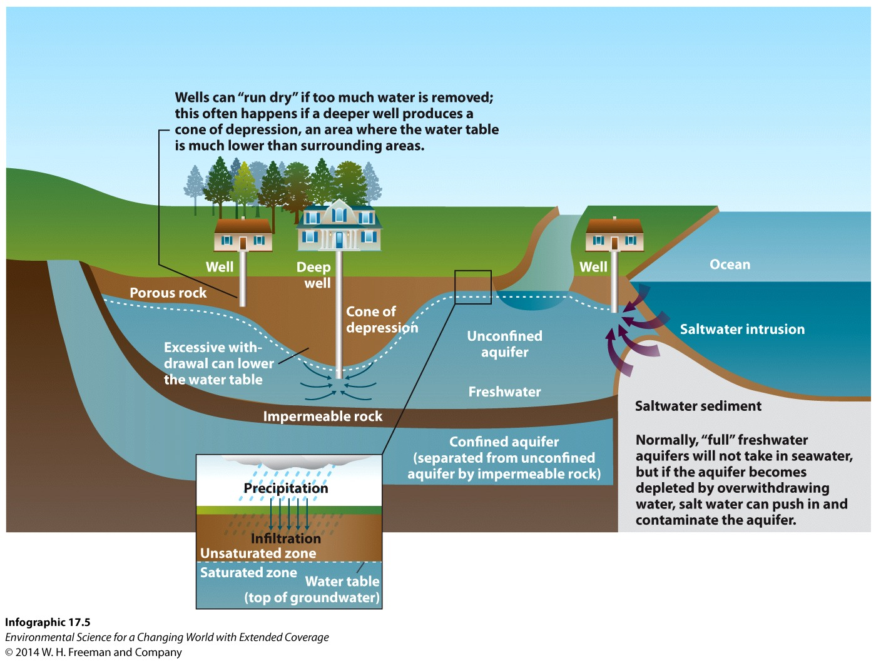
13) Increasing population also led to increases in wastewater: 100 __________ gallons/day of partially treated sewage water was flooding the Santa Ana River.
- When people move into an area, they bring with them additional demand for water and more waste. As Orange County became more populated, it was necessary to adjust to the highs and lows of the water supply. The existing project was expanded and more wastewater was pumped into the Groundwater Replenishment System.
- After much community discussion, the Groundwater Replenishment System went online in 2008: now 70 ___________ gallons of recycled water are pumped into wells daily.
14) Solving water ___________ is not easy. Some communities dam up rivers to create _____________ – but these lose water every day through evaporation.
15) Arcata, CA, converted a ___________ to wetlands and sends sewage water to be consumed by _______________ in order to purify it.
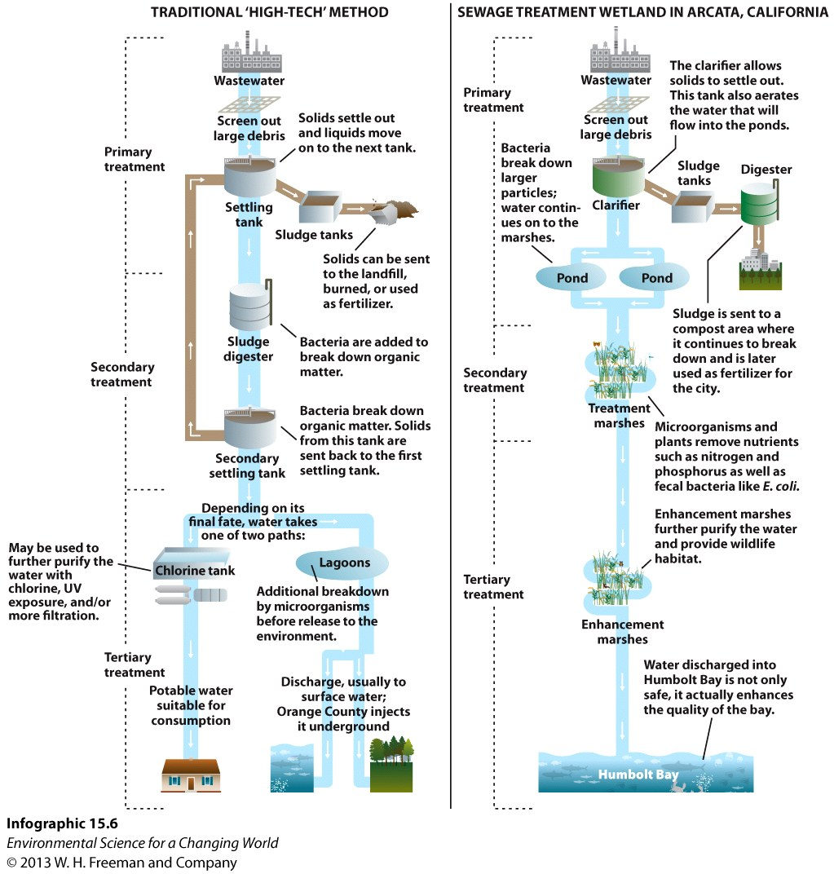
16) The Orange County system was costly: $487 _____________. A less expensive approach is water conservation.
17) It might be surprising how much water goes into the products we use on a daily basis.
- _____________ uses the most water and creates the most waste. Water-saving ______________ methods limit loss to evaporation and runoff, reducing water usage.
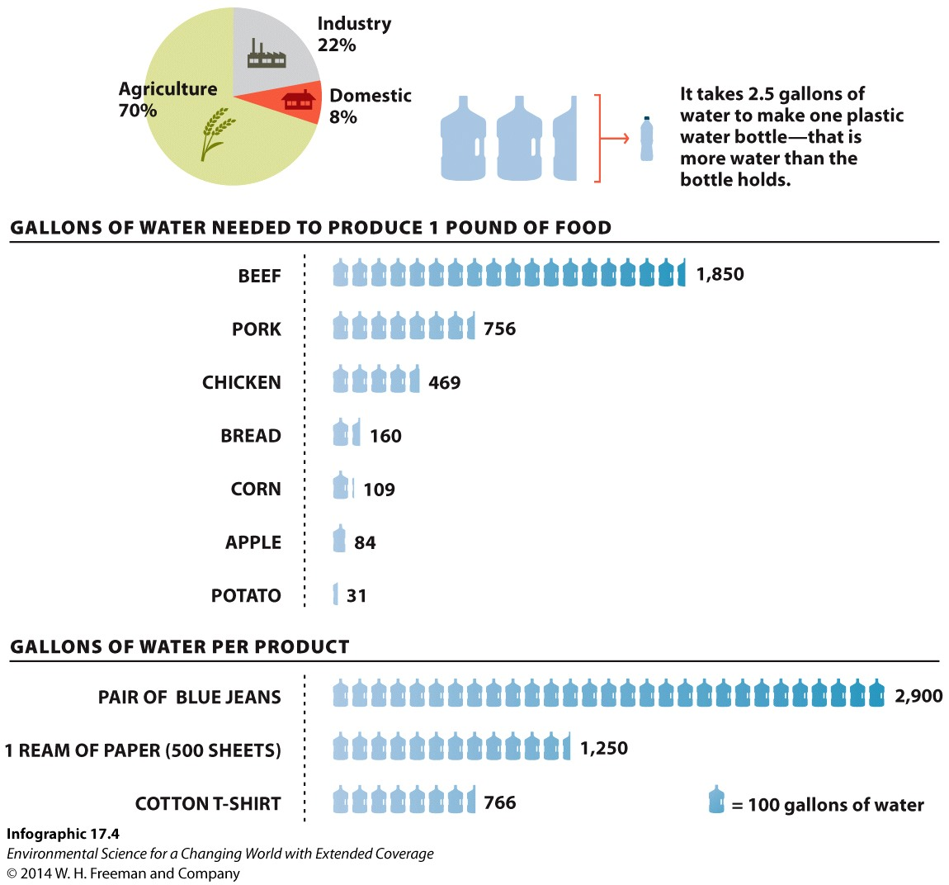
18) ________ changes in the household – such as low-flow toilets – can also save a lot of water. Buying less stuff and using less energy also _________ water – because much water is used to produce both.

19 Explain why people in many places in the United States complain of water shortages, while this map indicates they have access to clean water and sanitation.

20) If so much of Africa is grasslands and jungles, why do the inhabitants have so little access to clean water and sanitation?

