LIPIDS MIND MAP

DUE: Friday, October 24

As one last self-review of the organic chemistry concepts that we have learned thus far, you will be creating a mind maps for lipids.
Use your notes, textbook, and any other sources to create your mind maps.

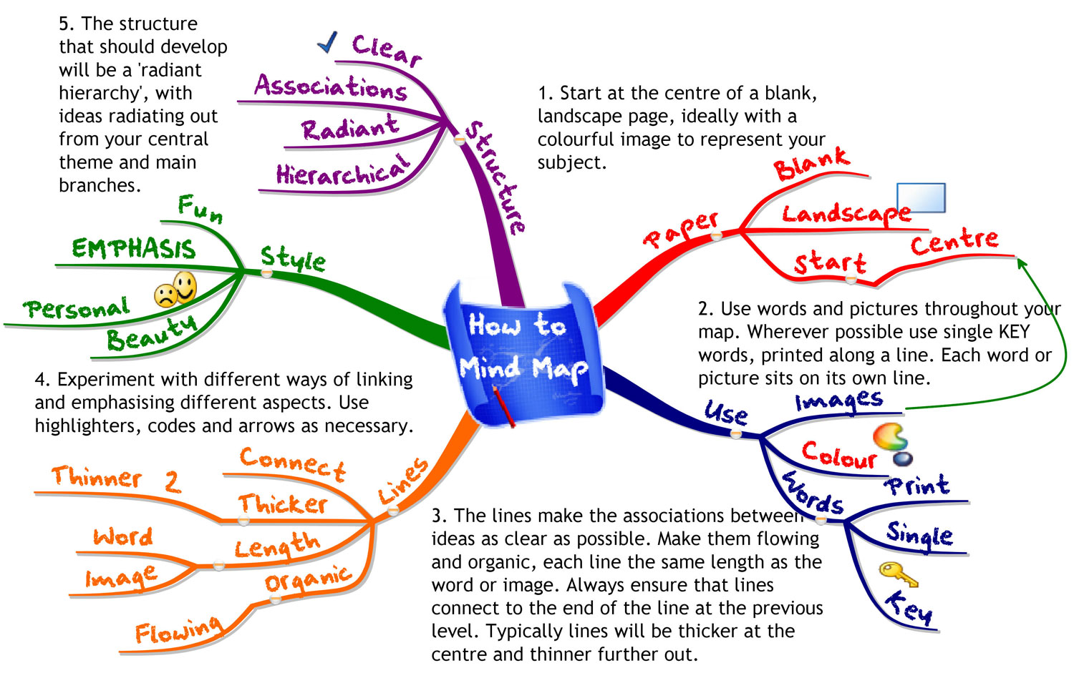
How to create a mind map:

Materials:
- 1-2 SHEETS OF BLANK COMPUTER PAPER
- COLORED PENCILS OR MARKERS
- YOUR NOTES AND YOUR TEXTBOOK

REQUIREMENTS: CREATIVITY AND COLOR!!! + THE FOLLOWING TERMS FOR EACH MIND MAP
Must include the following terms for the LIPIDS mind map:

- Phospholipid
- C, H, O
- Hormones
- Not soluble in water
- Triglyceride
- Steroids
- Estrogen
- Testosterone
- Saturated
- Unsaturated
- Double-bond
- Bent
- Straight
- Dehydration Synthesis
- Hydrolysis

- 3 Fatty Acids
- 2 Fatty Acids
- Fats, Oils
- Contains PO₄- (phosphate group)
- Glycerol
- When joined make 3 H₂O

** Extra credit points will be awarded for up to 5 more scientific terms/descriptions/examples that are added to each mind map. Circle the terms that you add so that I know what they are.
GOOGLE IMAGE SEARCH “MIND MAPS” IF YOU WOULD LIKE SOME MORE INSPIRATION

