Name: Date:

Chapter 21: AGriculture: raising livestock

CHECK YOUR UNDERSTANDING

5. Globally, what are the FAO’s livestock-rearing recommendations?

a. All nations should phase out the environmentally damaging CAFOs and bring back pasture-raised livestock.
b. The priorities for developed nations should be food safety issues and protecting farmers’ incomes.
c. Developing nations should focus on methods that increase food security and the income of small farmers.
d. Livestock rearing in general should be phased out in favor of plant-based food products.

6. Based on feed conversion ratios, it is more energy efficient to eat chicken than beef because:

a. a pound of ground beef has fewer calories than a pound of ground chicken.
b. chickens are more efficient than cows at converting the food they are fed into body mass, or the food that we eat.
c. chickens are lower on the food chain than cows.
d. unlike cows, chickens represent a gain for the human food supply, as they eat items we cannot (such as insects) and convert them into meat we can eat.

3. Compare the trade-offs of rearing cattle in CAFOs or on pasture. Which do you support? Explain.

CAFOs

Advantages:

Disadvantages:

PASTURE

Advantages:

Disadvantages:

4. What is the U.S. Farm Bill and how has it changed over time?

5. What is "eating lower on the food chain," and how might it help address some of the problems related to raising animals for food?

ANALYZING THE SCIENCE

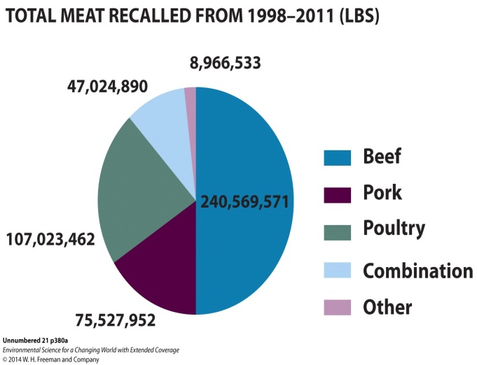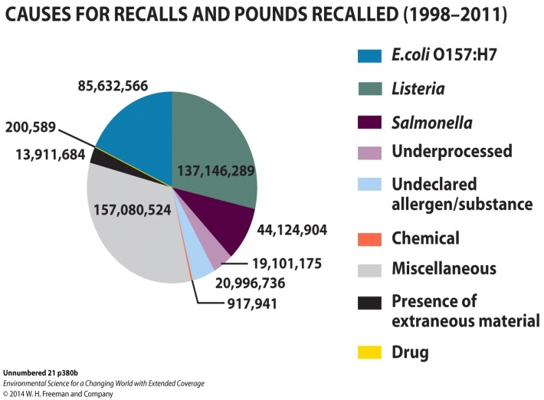

These two graphs represent data on meat recalls from 1998–2011, in pounds. Graphs are based on data from USDA Food Safety and Inspection Service (www.fsis.usda.gov).

INTERPRETATION
1. What type of meat was recalled most, and what is the most common reason for recalls?

2. For each type of food recall, calculate its percentage of total food recalls.

3. We are most likely to be exposed to Listeria by eating cold cuts like lunch meat. What is it about this type of food that increases our likelihood of getting sick if it is contaminated? Where does Listeria rank as a source of contamination?

4. Does the use of CAFOs increase or decrease the likelihood of meat recalls? Explain your answer.

Record ALL definitions from the 1st and 2nd reading below:

Vocab Word Definition

