Biology EOC Practice Test (from 2013 Updates with some short answer from 2012)
1 How is cellular respiration by plants similar to the burning of fossil fuels?
o A. Both release oxygen for organisms that are consumers.
o B. Both break down carbon-containing compounds.
o C. Both produce ATP.
o D. Both absorb light.
2 Which process increases genetic variation among whale offspring?
o A. Division of cells in mitosis
o B. Fertilization of egg cells
o C. Synthesis of proteins
o D. Assembly of lipids
3 Adding habitat is a solution to the problem of decreased butterfly populations in prairie ecosystems. What could be an unintended consequence of adding habitat for butterflies?
o A. Beneficial nutrients could be removed from the ecosystem.
o B. The air temperature could increase in the ecosystem.
o C. Materials new to the ecosystem could be introduced.
o D. The amount of light in the ecosystem could increase.
4 In mammals, the hormone insulin helps decrease the amount of glucose in blood. Which describes a negative feedback system between insulin and glucose?
o A. Small amounts of glucose in blood keep insulin from working properly.
o B. Insulin is constantly released to prevent low glucose levels in blood.
o C. Insulin causes the addition of large amounts of glucose to blood.
o D. High levels of insulin decrease blood glucose levels.
5 Months after a forest fire, some nonnative plants began to grow in the area. Why were these plants able to grow?
o A. The plants were able to survive without water.
o B. The plants were able to use the ash as chemical energy.
o C. The plants were able to thrive in the newly formed niches.
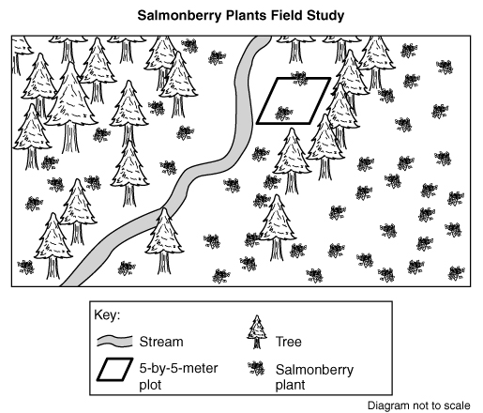
o D. The plants were able to mutate to adjust to the new surface materials.
Salmonberry Plants
Directions: Use the following information to answer questions 6 through 13.
Salmonberry plants can be found all along the Pacific coast. Salmonberry plants are a food source for many animals in Pacific coast ecosystems including hummingbirds, deer, and bear. Scientists conducted a field study to learn about salmonberry plant populations in different habitats in Washington.
Field Study Question: How does the salmonberry plant population vary by habitat?

Procedure:
1. Go to the salmonberry field study area. Record location, date, time, and temperature.
2. Choose a random location in the forest edge habitat.
3. Measure a 5-meter-by-5-meter plot and label as Plot 1.
4. Count the number of salmonberry plants in Plot 1. Record as Plot 1 for the forest edge habitat.
5. Repeat steps 2 through 4 for Plot 2 and Plot 3, choosing a new location in the forest edge habitat for each plot.
6. Repeat steps 1 through 5 for the stream bank and forest habitats.
7. Calculate and record the average number of salmonberry plants for each habitat.

Data Collected:
Location: Forest edge, stream bank, and forest habitats
Date and Time: May 1, from 11:00 A.M. to 2:00 P.M. Temperature: 10° C to 15° C
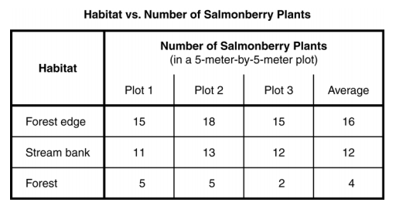
6 How could the validity of this field study be improved?
o A. Use a fourth habitat type in the field study.
o B. Count the number of trees in the field study area.
o C. Use three 1-meter-by-1-meter plots in each habitat.
o D. Count the salmonberry plants in four plots at each habitat.
7 Which output from bears is used by salmonberry plants?
o A. Carbon dioxide from bears is used for photosynthesis in plants.
o B. Oxygen from bears is used for photosynthesis in plants.
o C. Glucose from bears is used for respiration in plants.
o D. Water from bears is used for respiration in plants.
8 Blackberry plants are found in forest edge habitats. How could blackberry plants limit the population of salmonberry plants?
o A. Blackberry plants increase oxygen in the ecosystem.
o B. Blackberry plants lack flowers that attract bees.
o C. Blackberry plants produce dark purple berries.
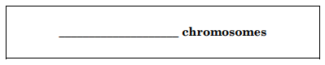
o D. Blackberry plants compete for resources.
9 Salmonberry leaf cells contain 14 chromosomes. How many
chromosomes will a new leaf cell contain after mitosis?
Write your answer in the box.
10 The results from the field study are shown in The Habitat vs. Number of Salmonberry Plants table. Describe a scientific reason for the results in the forest edge habitat and a scientific reason for results in the forest habitat.
In your description, be sure to:
• Describe a scientific reason for the results in the forest edge habitat.
• Describe a different scientific reason for the results in the forest habitat.
• Include data from the Habitat vs. Number of Salmonberry Plants table that supports each scientific reason.
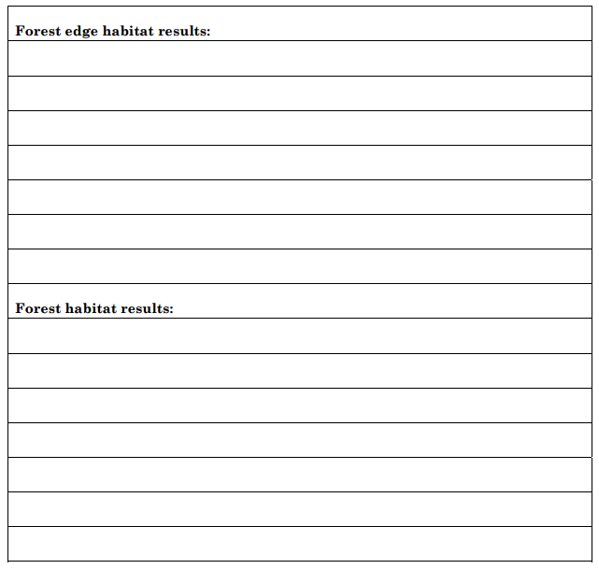
11 Which event might be evidence that the forest edge habitat is in equilibrium?
o A. A dead tree providing nutrients for a young tree
o B. A bird species leaving as temperatures increase
o C. A landslide damming the stream in the habitat
o D. A flood washing away topsoil from the ground
12 Salmonberry plant roots absorb minerals. What cellular process moves minerals across root cell membranes from an area of low mineral concentration to an area of high mineral concentration?
o A. Facilitated diffusion
o B. Passive transport
o C. Active transport
o D. Osmosis
13 Scientists wondered how the presence of the new type of grass could affect the population of salmonberry plants in a forest ecosystem. What kind of investigation would be most appropriate to answer this question?
o A. A field study because factors that are hard to control could influence the results
o B. A research paper because information is available about many kinds of plants
o C. A controlled experiment because all the variables can be kept the same
o D. A simulation because computers are more reliable than natural systems
Foaming Spuds
Directions: Use the following information to answer questions 3 through 6 on pages 14 through 17.
Mike and Kelsey were studying how hydrogen peroxide (H2O2) in cells breaks down to form water and oxygen. When this reaction happens, bubbles of oxygen gas are released, producing foam. This reaction is described as follows:
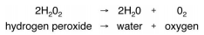
A protein named catalase, found in all cells including potatoes, increases the rate of this reaction. Mike and Kelsey used potato juice as the source of catalase to do the following controlled experiment.
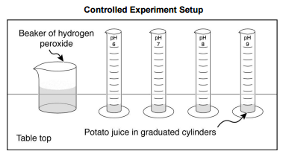
Question: What is the effect of the acidity of potato juice on the volume of foam produced when hydrogen peroxide is added to potato juice?
Prediction: As the acidity of potato juice decreases (higher pH), the volume of foam will increase.
Materials: graduated cylinders labeled pH 6, pH 7, pH 8, and pH 9 potato juice from the same potato, divided and adjusted to four acidities: pH 6, pH 7, pH 8, and pH 9 hydrogen peroxide (H2O2) beaker stopwatch stirring rods thermometer
Procedure:
1. Label four graduated cylinders, one for each acidity.
2. Put 10 milliliters of potato juice at pH 6 in the appropriately labeled cylinder.
3. Do the same for each of the other cylinders.
4. Monitor the room temperature to make sure the temperature remains the same throughout the investigation.
5. Add 5 milliliters of hydrogen peroxide to each graduated cylinder, stir for two seconds. Wait three minutes.
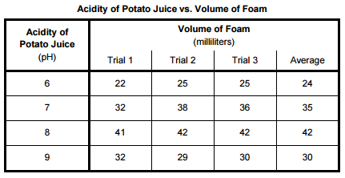
6. Measure and record the volume of foam in each graduated cylinder as Trial 1.
7. Clean all graduated cylinders and stirring rods.
8. Repeat steps 1 through 7 two times for Trials 2 and 3.
9. Calculate and record the average volume of foam for each acidity of potato juice.
Data:

14 How could Mike and Kelsey be more certain the results of their experiment are reliable?
o A. Test the reaction with other acidities of potato juice.
o B. Repeat the experiment the same way.
o C. Increase the volume of potato juice.
o D. Use a different type of plant juice.
15 Write a conclusion for this controlled experiment.
In your conclusion, be sure to:
• Answer the experimental question.
• Include supporting data from the Acidity of Potato Juice vs. Volume of Foam table.
• Explain how these data support your conclusion.
• Provide a scientific explanation for the trend in the data
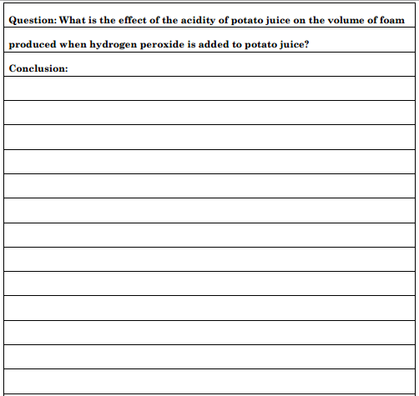
16 Plan a controlled experiment to answer the question in the box. You may use any materials and equipment in your procedure.
Be sure your procedure includes:
• logical steps to do the experiment  • two controlled (kept the same) variables  • one manipulated (independent) variable | • one responding (dependent) variable  • how often measurements should be taken and recorded
