Name: __________________________________ Per: 1 2 3 4 5 6
Bio Test #1 Study Guide
Characteristics of Life Review
Write the 8 characteristics of life and a brief description of each.

Choose an inanimate (non-living) item and identify and describe at least 4 characteristics of life that it does not possess. Item: _________________________
1. 3.
2. 4.
Biodiversity & Classification of Life Review
Eubacteria | Archeabacteria | Protists
Examples/Description: | Examples/Description: | Examples/Description:
Defining Characteristics: | Defining Characteristics: | Defining Characteristics:
Define biodiversity and explain why it is important.

Microscope Review
Directions: Fill in the name for each part.
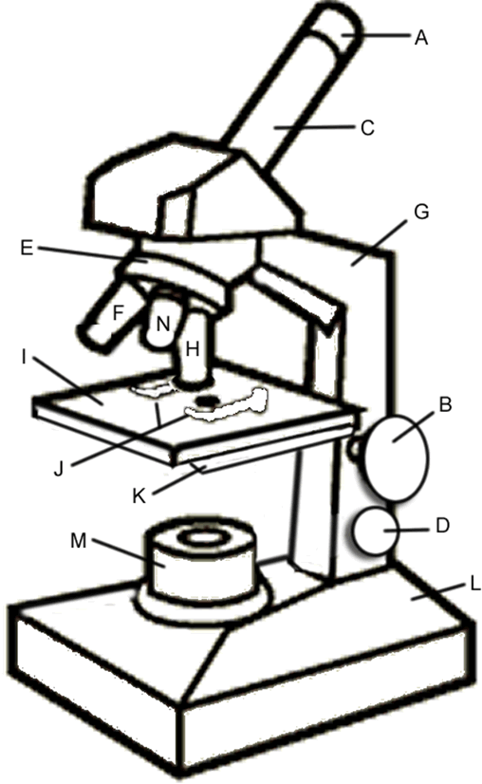
A:___________________________________
B:___________________________________
C:___________________________________
D:___________________________________
E:___________________________________
F:___________________________________
G:___________________________________
H:___________________________________
I:___________________________________
J:___________________________________
K:___________________________________
L:___________________________________
M:___________________________________
N:___________________________________

- What are the steps for focusing on a specimen with high power? (Start from the beginning…)

- What is the total magnification when looking through the 10X ocular and the lower power of 4X?

