Name:

Part 2: Dihybrid Crosses
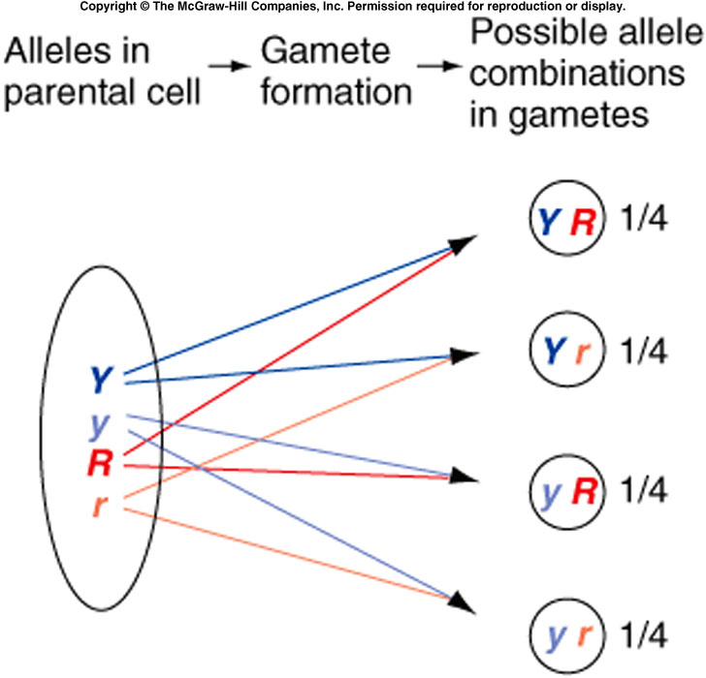
We will use four coins (two pennies and two nickels) to test the genotype and phenotype ratio which would result from a mating between parents who are heterozygous for each of two different traits. We call this a dihybrid cross. We will repeat the experiment in Part 1, this time completing 200 coin flips. Because we are looking at 2 traits, we will need different coins for each parent. One type of coin (penny) will represent one of the 2 traits contributed by the parent. The other type of coin (nickel) will represent the second trait contributed by that parent. There are 2 sides to each coin and 2 possible outcomes for each trait since each heterozygous parent carries 2 different alleles for each trait.

Do the results on the penny affect the results on the nickel? No, the flip independently from each other. In the same way, The genes for the two traits assort independently from each other into gametes. Mendel called this the “Law of Independent Assortment. “
14
Any 1 of 4 possible combinations may therefore turn up in any single game (sperm cell or egg cell). There are, therefore, 16 possible outcomes when the egg and sperm eventually meet.

Prelab Questions: You may not begin Part 2 of this lab activity until these questions are completed in your lab notebook and stamped.
- Use your notes to explain the Law of Independent Assortment in your own words.
- Following is a partially completed Punnett Square for a dihybrid cross. In it, both parents are heterozygous for brown eyes and carry the recessive trait for spinal muscular atrophy (SMA-a rare genetic disorder).
  - Write the four possible gamete combinations. Note: Always keep the alleles for the same trait together and put the dominant (capital letter) allele and the recessive (lower case) allele second.
  - Complete the Punnett Square.
  - Compute the odds of having a child with blue eyes.
  - Compute the odds of having a child with blue eyes and SMA.
  - Compute the odds of having a child with brown eyes and SMA.

B = brown eyes; b = blue eyes
N = normal Central Nervous System development; n = Spinal Muscular Atrophy

 |  | FATHER
MOTHER |  | BN | Bn | bN | bn
 | BN
 | Bn
 | bN
 | bn

In Pea Plants,
- Rough seed shape (R) is dominant over smooth seed shape (r).
- Yellow seeds (Y) are dominant over white seeds (y).

Investigative Questions:
What is the effect of crossing 2 rough seed shape, yellow seeded heterozygous parents on the resulting genotypes of the offspring?

Hypothesis:
Write a hypothesis for the investigative question and use a Punnett Square and the genotypic ratios for this cross as the “because” part of the hypothesis. Mendel observed this outcome many times during his testing. The results were repeated with great precision.

Procedure:
- Choose one person to be the Director and one person to be the data collector.
- Determine the 4 possible gametes produced by either parent.
- Create a Punnett square to show the possible offspring from such a cross.
- Determine the possible seed shape and color of all offspring whose parents are each heterozygous for the two traits.
- Copy the following data table into your lab notebook.
- Label the heads side of both pennies “R” and the tails “r.”
- Label the heads side of both nickels “Y” and the tails “y.”
- Label the second column of the table (below coin combination) with the correct genotypes.
- Label each box in the first column of the data table “Phenotype” with the appropriate phenotype.
- From the outcomes in your Punnett Square, enter the “expected probability” for each genotype. This is done by counting up the boxes in the Punnett Square that match each genotype. Remember that some of the alleles in your data table are produced in more than one way (ex. Heads-tails is the same as tails-heads). Then take the number of Punnett square boxes that match one genotype and divide by 16 to get the probability of that outcome. (Number of Squares for a Genotype/16 = Probability)
- Toss both coins 200 times.
- Record your results as appropriate hash-marks in the appropriate boxes under “Tally.”
- When you finish, divide the results of each genotype (under “Tally”) by the total of tosses (200) to obtain the “Experimental Outcome.”

Data Table B-Dihybrid Cross
Phenotype | Coin Combination |  |  |  | Tally | Expected Probability | Experimental Probability (outcome)
Rough, yellow seeds | PENNY HEADS | PENNY HEADS | NICKEL HEADS | NICKEL HEADS |  | 1 ÷ 16 = 0.0625 | (tally) ÷ 200 =
 | GENOTYPE(S)  RR only |  | GENOTYPE(S)  YY only
 | PENNY HEADS | PENNY HEADS | NICKEL HEADS | NICKEL TAILS
 | GENOTYPE(S)  RR only |  | GENOTYPE(S)  Yy or yY
 | PENNY HEADS | PENNY TAILS | NICKEL HEADS | NICKEL TAILS
 | GENOTYPE(S) |  | GENOTYPE(S)
 | PENNY HEADS | PENNY TAILS | NICKEL HEADS | NICKEL HEADS
 | GENOTYPE(S) |  | GENOTYPE(S)
 | PENNY HEADS | PENNY HEADS | NICKEL TAILS | NICKEL TAILS
 | GENOTYPE(S) |  | GENOTYPE(S)
 | PENNY HEADS | PENNY TAILS | NICKEL TAILS | NICKEL TAILS
 | GENOTYPE(S) |  | GENOTYPE(S)
 | PENNY TAILS | PENNY TAILS | NICKEL HEADS | NICKEL HEADS
 | GENOTYPE(S) |  | GENOTYPE(S)
 | PENNY TAILS | PENNY TAILS | NICKEL HEADS | NICKEL TAILS
 | GENOTYPE(S) |  | GENOTYPE(S)
 | PENNY TAILS | PENNY TAILS | NICKEL TAILS | NICKEL TAILS
 | GENOTYPE(S) |  | GENOTYPE(S)

Analysis Questions:
- How closely did your data resemble the expected probability for the monohybrid cross? Does your data support the data and conclusions published by Mendel?
- Does your data more closely match Mendel’s for the dihybrid cross than they did in Part A (a monohybrid cross)?
- Whatever your answer, explain why you obtained the outcome you did. (Why do the data from Part B match Mendel’s more closely- or less closely- than the monohybrid cross in Part A?)
- Students almost never obtain a perfect match for the expected outcomes. Why do you think this is so?
- If we combined the data from the whole class, do you think your data would more closely or less closely match Mendel’s results? Why?

Extra credit: Complete a Punnett Square for any tri-hybrid cross.

