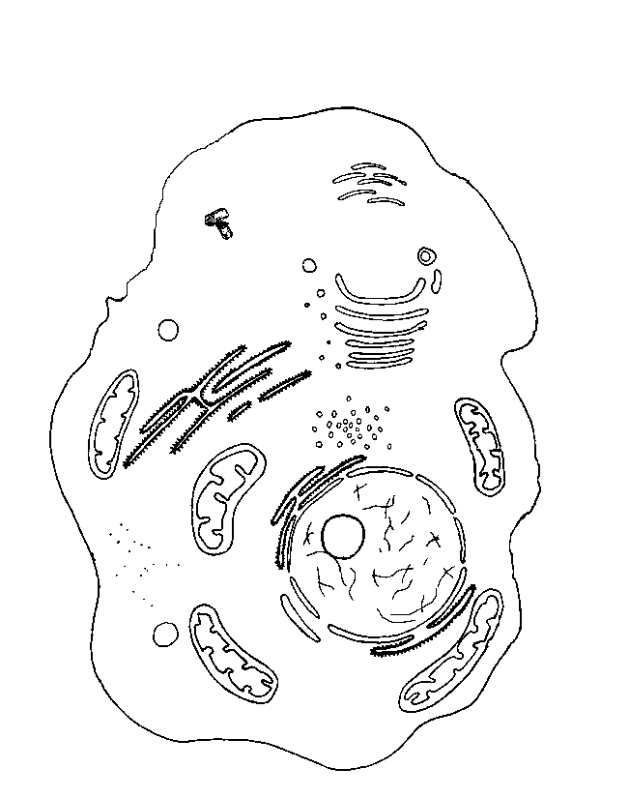
1st Semester Biology Review Activity

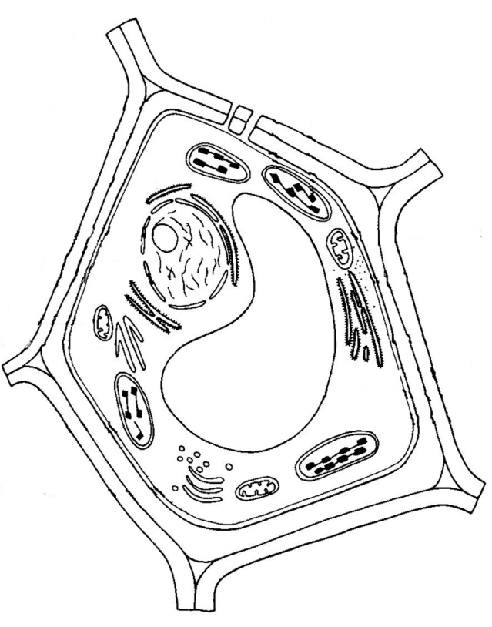

A
B

C
D
E
F
G
H
I
J
K
I. II.
I.

- What type of cell is number I? __________________________________
- What type of cell is number II? __________________________________

Write down the name of the cell structure and the function from the corresponding label above.
3. (A) ________________________________________________________
4.(B) ________________________________________________________
5.(C) ________________________________________________________
6.(D) ________________________________________________________
7.(E, just the hole) _____________________________________________
8.(F) ________________________________________________________
9.(G) ________________________________________________________
10. (H, whole thing) _____________________________________________
11.(I. the whole thing) ___________________________________________
12.(J) ________________________________________________________
13.(K) _________________________________________________________

Microscopes
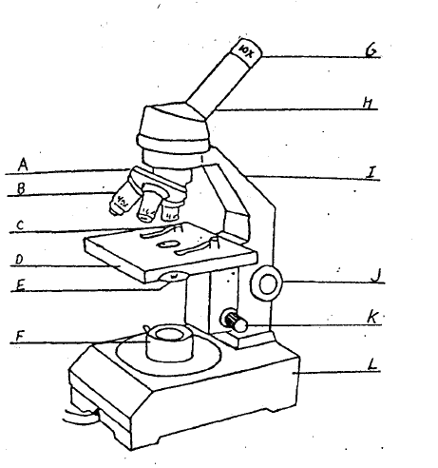
Write down the name of the microscope part and the function
(A)___________________________________
(B) ________________________________________
(C) _______________________________________
(D) _________________________________________
(E) ________________________________________
(F) ________________________________________
(G) ________________________________________
(H) ________________________________________
(I) ________________________________________
(J) _________________________________________
(K) ________________________________________
(L) __________________________________________________

Ecology
- Put the food web into an ecological pyramid that begins with 34,510 kg.
- Label the pyramid with terms such as heterotroph, autotroph, primary consumer, herbivore, etc….
- Circle a food chain that has 4 feeding levels
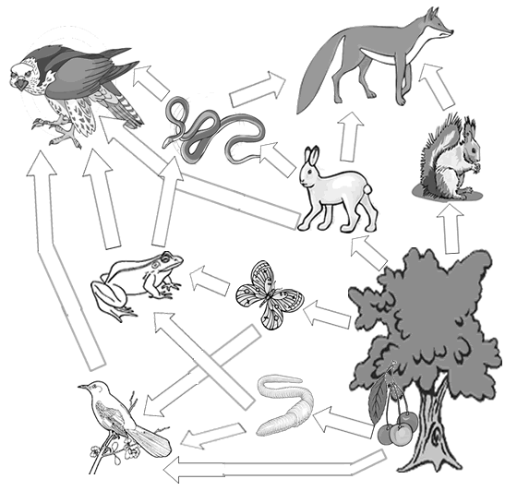

- Identify 5 predator-prey relationships in the food.
- Rabbits are an important part of the food web. A disease kills the majority of the rabbit population. Name two consequences to predator-prey relationships in the food web.
List the 8 characteristics of life:

Populations
For each graph label where the births are increasing and decreasing and where the deaths are increasing and rising.

What kind of graph is this?_____________________
What kind of graph is shown below?_________________

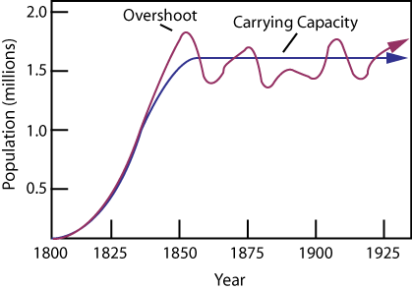
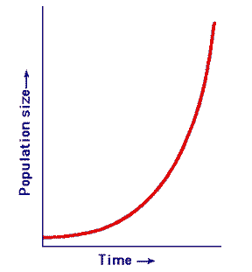

Explain why this graph is an example Explain why this graph is an example of a negative feedback loop
of positive feedback

Study these drawings, which show the presence and loss of turgor pressure. Then answer the questions based on your understanding of the results.

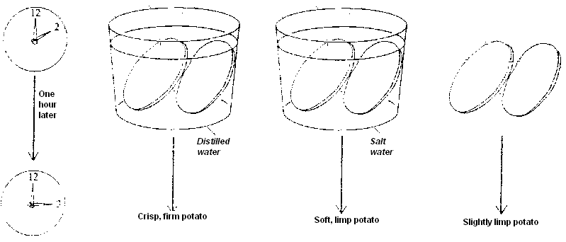

- How would you describe the stiffness and texture of the sliced vegetables (not placed in liquids) after an hour?

- How would you describe the stiffness and texture of the vegetable slices left in distilled water?

- What happened to the turgidity of the cells left in distilled water?

- How would you describe the stiffness and texture of the vegetable slices soaked in salt water?

- Do these slices have greater of lesser turgidity than the slices left out in the air?

- What conclusions can you draw from the results?

7. Explain the movement of water in this experiment.

Matching section: Match the term and definition.

Term Definition
- _____ Isotonic

- _____ Plasmolysis

- _____ Solvent

- _____ Cytolysis

- _____ Hypertonic

- _____ Hypotonic

- _____ Passive Transport

- _____ Semi-permeable

- _____ Solute

- _____ Phospholipids

- _____ Fatty acids

- _____ Diffusion

- _____ Osmosis

- _____ Turgor

- _____ Pinocytosis

- _____ Active Transport

- Main component of the cell membrane

- What is being dissolved; there is less of it in the solution.

- Type of transport which happens without the expenditure of energy.

- Word that describes the cell membranes ability to only let some solutes through.

- Molecules moving against the concentration gradient.

- Solution with equal levels of solutes on both sides of a membrane.

- Random natural movement of molecules from a high concentration to a low concentration.

- Plant cell shrinking when in a hypertonic environment.

- Cell drinking.

- Movement of water through a membrane.

- Portion of a phospholipid which is hydrophobic.

- When comparing two solutions, the solution with more solute.

- When comparing two solutions, the solution with less solute.

- Type of osmotic pressure which helps a plant maintain shape and support

O. What does the dissolving; the more plentiful substance in the solution.

P. When a cell bursts after being placed in a hypotonic solution

Draw a triglyceride molecule (long hand) in the space below that has hydrocarbon chains composed of 10 carbons. Circle and label the glycerol and 3 fatty acid tails. Answer the questions below

26. What is the name of the process that combines part A and part B to make a triglyceride?

______________________________________________

27. What “waste” molecules are formed from this process?___________________________

28. How many of these waste molecules form?_____________________________

29. What is the molecular difference between a saturated and unsaturated fat? Draw the difference in the space below?

What are 3 general differences between a saturated and unsaturated fat?

Draw a phospholipid molecule (long hand) in the space below that has hydrocarbon chains composed of 10 carbons. Circle and label the phosphate group the glycerol and the 2 fatty acid tails.

Why is the phospholipid important?

